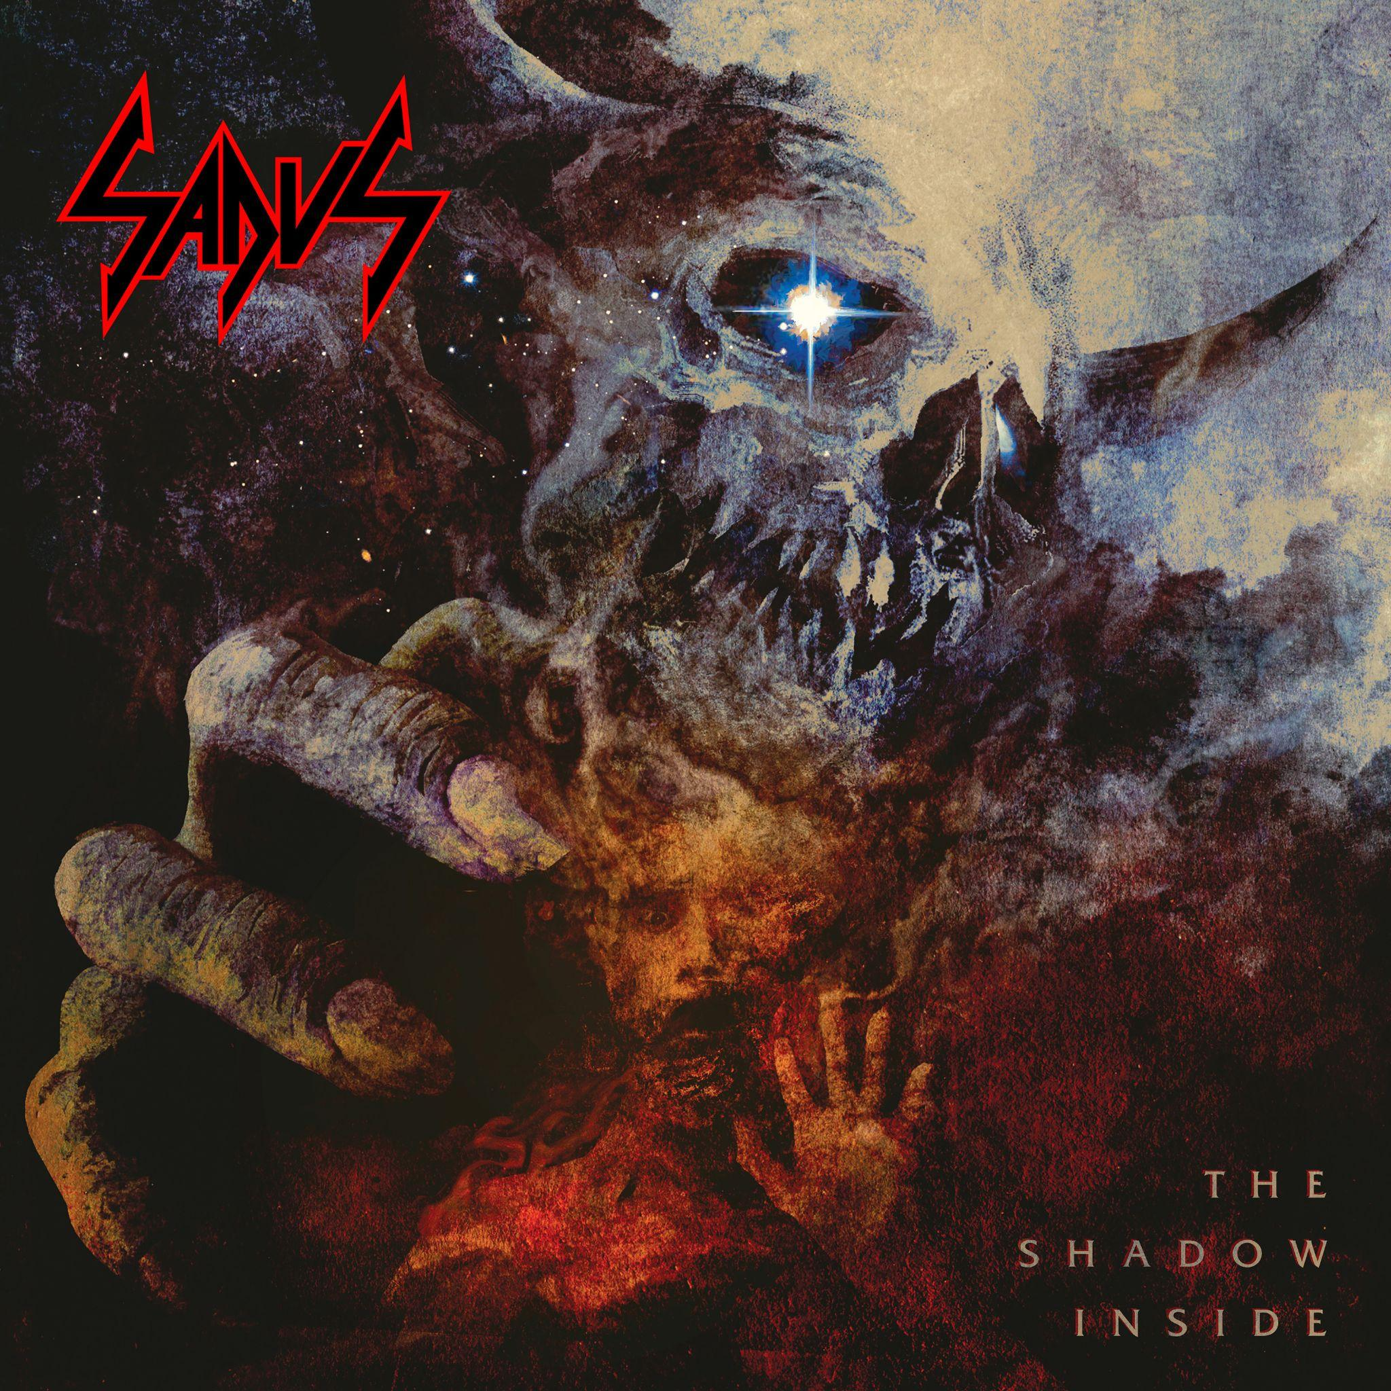

SADUS
The Shadow Inside

Release Date: November 17th , 2023

Line up: | SADUS online:
Darren Travis | Vocals/Guitar  Jon Allen | Drums | www.facebook.com/sadusguy/  www.twitter.com/@SADUS_killteam  www.instagram.com/Sadus_Official  www.youtube.com/@SADUS6666
It has been sixteen long years since the monstrous sound of SADUS last bestowed a new record upon the world, but the time has finally arrived. This November, Nuclear Blast Records proudly presents the triumphant return of the unconquerable SADUS with their sixth full-length studio album, titled The Shadow Inside.
Adorned with the compelling artwork of Travis Smith, the album cover depicts an all-consuming demon of the cosmos fiercely enveloping a tortured soul beneath, perfectly encapsulating the vision and duality that the songs on this record deliver. Founder and drummer Jon Allen shares his excitement about working with Travis once again, reminiscing about their collaboration on Elements of Anger. He points out that several tracks on the new album, such as ‘The Devil In Me’ and ‘The Shadow Inside’, revolve around the idea of an internal entity constantly pushing us. At times, one might find themselves at the edge of reason, attributing their actions to the shadow within, an external force they blame for their choices. While not a concept album per-se, every song deals with life decisions and the importance of taking responsibility for one's actions to unlock the best life has to offer. The track ‘The Shadow Inside’ boasts a heavier and slower tone, with a touch of classic, gut-wrenching grind, creating a fitting climax to the album.
A formidable darkness flows through tracks like ‘Anarchy’. Evidently influenced by the tumultuous post-Covid times of mass hysteria, looting, and general loss of control, the melody reflects this chaotic
environment. Allen describes the track as “more straightforward and in-your-face, hitting listeners right in the gut.” Despite the intensity, SADUS manages to retain their signature death/thrash blend, staying true to their old-school roots. The aggression remains palpable, allowing their music to speak for itself with raw, unapologetic power.
‘Scorched and Burnt’ follows suit, with its steady beat and chaotic vocals seamlessly intertwining with blistering guitar work. The track gradually transitions into an impassioned melody, igniting a fiery explosion as the song nears its conclusion. Although inspired by the literal wildfires that plagued California during its creation, ‘Scorched and Burnt’ delves deeper into the idea that individuals often feel like someone or something is constantly out to get them. Yet, in the end, the song urges unity, recognizing that every action, even in chaos, ripples through the lives of others.
The process of creating The Shadow Inside was unhurried and unencumbered by unnecessary roadblocks. SADUS allowed their creativity to flow naturally, collecting riffs and writing together in person. The band took their time, nurturing and developing their musical ideas until they evolved into the powerful tracks we hear today. Allen emphasizes that their drama-free and family-oriented approach to making music is one of the reasons their sound speaks so powerfully to their fans. Collaborating with Juan Urteaga of Trident Studios added another layer of refinement to the album, as his expertise in death metal played a vital role in shaping its overall sound.
All that being said, SADUS is not a band that simply stands apart from the crowd for the sake of being different. They stand tall, unswayed by mass hysteria and media influences, choosing to make their own decisions and encourage others to do the same. In a world filled with disinformation and false flags, they emphasize the importance of being smart, using common sense, thinking for ourselves, and remaining aware of our surroundings.
As November approaches, the anticipation for The Shadow Inside is sure to grow. With their uncompromising vision, SADUS continues to stand as a beacon of authenticity and integrity within the heavy metal community, forever forging their path in the ever-evolving landscape of music.

